**19 December 2021**

**Summative Assessment:**

**BI System Business Case**

**Company: Ayaki**



**Lecturer: Dr Christine Fidler**

Contents

Section 1: Introduction To The Business Case 2

Section 2: The BI Systems Proposal 2

2.1 Proposal Alignment With Strategic Objectives 3

2.2 Analysis Of Competitors' BI Systems 3

2.3. Existing MSS Evaluation 4

2.4 The Proposed BI System: Technical Configuration 5

3. Cost-Benefit Analysis 6

4. Risk Assessment 8

5. Summary 9

Appendix A: Company Overview 10

A1. Company Name & Overall Purpose, Size, Location(S) 10

A2. Principal Products/Services 10

A3. Overview Of Customers/Suppliers 10

A4. Information Regarding Strategic Objectives; Mission, Vision And Strategy 10

A5. Organisational Structure 11

A6. Overall IS/IT/MSS Overview 12

Appendix B: Development Discussion 13

References 18

# Section 1: Introduction to the Business Case

This business case is for a famous e-commerce wellness company located in Lagos, Nigeria, called Ayaki. The business case aims to evaluate the company's existing Business Intelligence System by analysing its overall IT/IS/MSS to what solutions it provides to the business and creating a Business case proposal for improvement in performance as requested by the board of directors. This proposal justifies implementing a new human resource management dashboard for employee performance within Ayaki.

The key deliverables of the proposal are as follows:

* Automate timesheet submission by providing an online submission portal
* Employee information updated in the existing ERP system
* Develop a Human Resource Dashboard for salary analysis, absenteeism and monthly analysis by each department, date range, gender, seniority and age.

The deliverables will provide the Executives with an at-a-glance interface of employee performance and workforce productivity. The new BI system will align with the company's strategic framework. An evaluation of the BI systems used by Ayaki's competitors, i.e. other plant-based wellness companies in Nigeria, will be conducted. Finally, the proposal will suggest a technical configuration and develop a cost-benefit analysis of the BI system's investment while conducting a risk assessment.

# Section 2: The BI systems proposal

The proposal aims to provide the management with information on the business problems on how much the company spends on salary payments by department, date range, gender and age. Additionally, from the submitted timesheet, the proposal aims to answer questions on the average annual leave days, the remaining leave days, sick and reasons for absenteeism in the company and the overall cost to the company. Furthermore, the proposal aims to develop a monthly summary of the workforce productivity to answer questions on terminations, hiring, employee performance and training.

The complete system requires updating employee information on the current Excel Spreadsheet and importing it to the ERP. The manually submitted timesheets will require an automated submission process online to the HR department. The submitted timesheet will be stored as excel tables and imported to the ERP. Therefore, the data for implementing the new HR dashboard will be available in the ERP and connected to an analytics tool using the SQL server to perform ETL (extract, transform, load) functions. After the data has been used to develop meaningful insights into the dashboard, the dashboard will serve as a management support system for the Executive and Board of Directors to improve workforce productivity and enhance staff management. This dashboard will serve as a precursor to other dashboards developed in the future.

## 2.1 Proposal alignment with Strategic objectives

During the Board meeting in December 2020, Ayaki's strategic objective framework was updated (See Appendix A4). Although the board did not know the exact questions it wanted the BI dashboard to answer, the expectations for improving the current system were highlighted in detail. The main strategic objective agreed upon at the meeting was to drive efficiency and workforce productivity by reducing material usage, energy and logistics costs, and minimising wastage. The first step is to eliminate material usage, energy and logistics- automating the manual (paper) submission of timesheets will require an online submission system. Each employee's timesheets will be logged automatically into the Excel spreadsheet and imported into the ERP system. This will save the company any cost of physical paper and file storage.

Furthermore, the automated timesheet submission system's implementation will eliminate waste of paper, space, and printing costs, contributing to an improved environment and saving costs. Therefore, the employee information stored in the ERP system is updated as it has been dormant. Finally, this proposal aligns with the objective of driving efficiency and workplace productivity; the ERP system will serve as a management support system for connecting to the SQL server and developing analytics dashboards about the amount paid to employees, absenteeism and a monthly overview of employee performance which will contribute to Ayaki's decision support system.

Ayaki's second objective aims at maintaining the leading position within its geographical area, i.e. Nigeria. The recent awareness about the Hemp plant's benefits resulted in more plant-based wellness retailers. Therefore, this proposal will evaluate the competitor's BI system for its workforce and provide Ayaki with ways of leveraging the new BI system to stay ahead. Finally, the new BI system's absenteeism dashboard will help with time allocation to achieve the last objective of meeting consumer and customer expectations. The new BI system's management reporting capabilities will allow the Executive to analyse the workforce and develop reports to share with prospective investors and clients.

## 2.2 Analysis of Competitors' BI Systems

Ayaki's office is located in Lagos, with an online retail store available to all customers in Nigeria; there will be competing across the country. There are two main competitors for Ayaki. The first is Olami, located in Abuja, Nigeria, and the other is Izuba, located in Enugu, Nigeria. A brief description of the competitor's business, Evaluation of their BI system and comparison with Ayaki's proposed BI system is as follows;

**Olami**

Olami is a wellness company in Abuja, Lagos. The main similarity to Ayaki is that it offers CBD Oil and Butter. This company is more minor than Ayaki, and it currently employs part-time workers to assist the owner with packaging and storing the finished products and delivery to customers. It is similar to Ayaki because they both use the OLTP to process online orders; however, sales information is calculated in Excel Spreadsheets. Hence, the owner uses their discretion to evaluate the raw data to view business performance. The employees are paid an hourly rate calculated using a paper spreadsheet at the end of the month, so the company does not have any information regarding employee management. The salary is paid in cash, and the no system records absenteeism. After looking at this competitor's BI system, I believe this proposal will give Ayaki tremendous leverage over Olami. Ayaki has a more structured workforce with a management support system to evaluate its business performance. Unlike Olami, Ayaki records its employee's time and salary intake in an Excel spreadsheet. Therefore, the salary analysis dashboard will provide meaningful insights into the amount spent on employees and the business's cost of absenteeism.

**Izuba**

This company is located in Enugu, Nigeria and has been in existence before Ayaki. Like Ayaki, they provide the same CBD wellness products. The only advantage Ayaki has over them is that the employee details are stored in the ERP even though it's not operational in the business support system. Izuba has an advantage of analysis by already implementing a BI system in its finance department that uses a payroll dashboard that shows the amount spent on the employees. They get all their figures from the finance spreadsheets and connect them to Tableau (an analytical software). Their internal data analyst provides the management with meaningful insights from the data to form a report. The proposal to use the employee details to derive a dashboard of monthly workforce productivity analysis will give Ayaki further leverage over Izuba. This proposal will use similar software to Izuba called Power BI to implement its dashboard design. Ayaki's Executives will better understand its employees and perform better than Izuba.

## 2.3. Existing MSS evaluation

Ayaki's current management support system uses an ERP with various modules that cater to each company section (See Appendix A6). This section will briefly summarise the current management support system and how the BI system proposal can provide some improvement.

The current system Ayaki uses to pay its employees is by receiving manual timesheets and logging them into an Excel Spreadsheet with predefined formulas to calculate the total amount to pay its workers' salaries. The current system will be modified to perform better with the modification and improvement.

First, the manual method of collecting timesheets means that some timesheets may be logged incorrectly or lost in the filing process. This proposal will integrate an automated timesheet form into Ayaki to log their timesheets using an online portal every Friday. The timesheets will be automatically populated into an excel spreadsheet with each employee's name and the department. Therefore, instead of just sending the spreadsheet to finance for salary payment, the data will also be updated to the ERP's HR module.

Secondly, the current system records employee information but does not analyse it. At the start of each year, the employees are allowed 25-day Paid-Time off and five sick-leave days. The data is currently stored in an Excel Spreadsheet by Department and imported to the ERP alongside employee information, but they remain dormant. Therefore, it will require updating the data in the ERP the current workforce details, i.e., highlights, terminations, new hires, training by departments and leave times.

Finally, the current system does not provide the company with insights into its workforce's cost. Therefore, with the salary, absenteeism, and monthly analysis dashboard, the Executives will clearly understand the workforce's at-a-glance performance and identify other areas requiring improvements as it aligns with its strategic objectives to drive efficiency and workforce productivity.

## 2.4 The proposed BI system: technical configuration

The proposed BI system's technical design will utilise existing architecture within and outside the organisation. Additionally, it will identify the requirements for the new BI system.

The current architectural infrastructure for Ayaki's management support system obtains data in tables from its departments as Excel sheets and stores them in the ERP system. The only competitor similar to Ayaki is Izuba, and they also use Excel spreadsheets to calculate employee salaries from timesheets, but their finance department does this. Their current architecture is more advanced than Ayaki’s because they have utilised analytical software for developing insights.

With this in consideration, Ayaki's BI system's new technical configuration will acknowledge the competition's architecture.

The same ERP system with the HR module will remain in the new architecture, requiring no data transfer. The data source will be improved by integrating a new online system to remove the manual submission. The HR data in the ERP system will be updated to include leave days, termination details, employee information, training and demography data. Additionally, the database will be examined for any license updates, diagnoses and troubleshooting. After adequately analysing the database, the required HR tables will be extracted into an OLAP cube using ETL processes. The OLAP will contain metadata defined by the HR manager. The OLAP cube serves as the data source for the new analytical software – Power BI will connect, and reports will be generated relative to the OLAP cube. The HR manager will specify the granularity and Time dimensions for the dashboard (Cecilia, 2014). The analytical software provides related dimensions and facts tables in the structure of a "Star Schema" that provides integrated data for specific functions in designing the dashboards with drill-down, slice and filtering.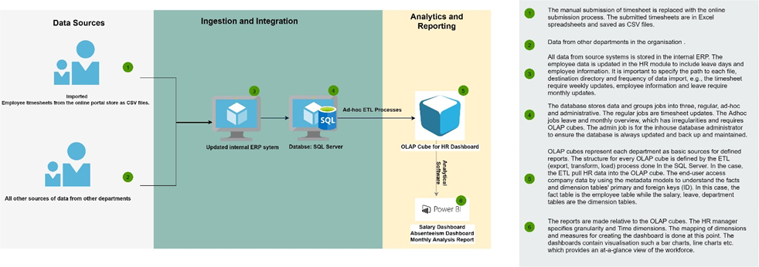

Figure Proposed Modern Data Architecture for Ayaki

The new architecture does not require introducing new hardware but should be considered when Ayaki decides to open a physical store or other branches outside Nigeria.

# 3. Cost-benefit Analysis

A vital part of implementing the proposed BI system is to evaluate the cost to the company and review the potential return on investment (ROI). Below is the cost-benefit analysis;

First, the new online timesheet portal eliminates manual submission. The available Microsoft license (i.e. Microsoft 365) to use Excel will include the license for Microsoft Forms. At the same time, it is available online and populates the excel sheet once submitted. Therefore, there is no need to purchase a new request for the form. The database administrator will prepare the form. However, one-day training will be required to demonstrate how to submit the documents to the employees at no extra cost to the company.

The software license for the Microsoft 365 software requires upgrading to the latest 2020 version because the current one was in 2016; this will cost a one-time annual purchase of £119.99 for the business license package. The ERP system will require an upgrade for the HR module. A software developer's service will be required to install the newest version of the module, and the HR manager will develop the data nomenclature, which should be completed in 5 days. Hiring a software developer is £360 per day; therefore, the total cost is £1800.

The database will require minimal configuration because the database administrator already maintains it. Therefore only the upgraded module in the ERP system will need any design. This will not require any cost but will take two days to complete. However, the IT manager will investigate and approve the data source, which takes one day to complete.

Finally, Power BI's new Analytical software will require a license purchase. The recommended license for Ayaki is the Power BI pro user license which is priced per user at £7.50, therefore, £90 per annum. This license comes with self-service and modern BI in the cloud - cloud storage so no data loss, i.e. Software-as-a-service capabilities, ability to collaborate, publish to the company website, share reports, and perform ad-hoc analysis – monthly analysis. This is great for Ayaki because, in the future, it will allow additional data analysts to create accounts with their purchased licenses. A Power BI developer will be needed to make the dashboards and reports for Ayaki. The Power BI developer rate is £720 per day, and 15 days will be required; therefore, the total cost is £10,800. Additionally, a data analyst will be required to support Ayaki by refreshing the data or performing further queries to develop insights. A data analyst's average annual salary is £60,500.

The overall system requires a professional test analyst to evaluate before deployment. A test analyst's cost for one-day is £500, which is the time needed for evaluation. Once the test analyst approves the deployment system, the HR manager and staff will need the training to update the ERP module, import and export timesheet, leave tables and interact with the dashboard. A Power BI consultant will be required to train the staff for three days at £400 a day – the total is £1200. Therefore, the cost for 12 months is;

**COST**

Online form – no additional cost

Timesheet submission training – no additional cost

Microsoft 365 – £119.99/pa

Software Developer - £1800

Database Administrator – no additional cost

Power BI License - £90/pa

Power BI Developer - £10,800

BI Analyst – £60,500/pa

Test Analyst - £2,000

BI consultant - £1,200

Total cost = **£75,009.99**

The net income for Ayaki is the total revenue made minus the cost of implementing the BI system investment. The average amount of money Ayaki makes each week from orders on the online retail store is £16,230. The annual amount in 52 weeks (12- months) is **£843,960.**

**ROI**

The return on investment for implementing the BI system within 12 months will be calculated as follows;

1025.13% return on investment (10:1) proves the investment will be worth a high return for Ayaki.

# 4. Risk Assessment

The following have been identified as the significant risks for this proposal, based on Moss and Are (2003) 's Risk Assessment Matrix. Each assessment criterion is assigned a colour system similar to green, Amber, and Red traffic lights. In the end, the overall risk for the proposal BI system project is determined.

Technology – **Green**

Although the BI system requires migrating to a digitised system, upgrade, and a few installations, the task's risk is green. The current database server allows the business to scale vertically by adding CPUs and RAMs. Therefore, the 6 GB of hard-disk space required to perform this task is available. There is no expected server traffic because the current server is agile and has resources that quickly perform installations. Additionally, the Power BI software is configured with data connectors to connect with the database seamlessly.

Complexity – **Amber**

The new BI system affects the current system as it introduces a new method of timesheet submission; however, it utilises Ayaki's existing architecture. The significant change is the migration from manual timesheet submission to electronic, i.e. online and updating the ERP HR module. Hence rating is medium.

Integration – **Amber**

The integration process requires introducing two new software, i.e. timesheet and analytical software. The process will not be extensive because the new software will flow with the existing infrastructure.

Organisation – **Green**

The executives and the HR manager highly welcome the prospect of a new BI system. The BI system will solve the strenuous filing system, wastage, and lack of clear understanding of its workforce. Although training is required to get them on board, the organisation believes it is worth the investment to increase driving efficiency and workforce productivity.

Project Team – **Green**

The project team for this BI project has extensive experience implementing BI systems. The HR manager has worked in various sectors and understands an exact metadata model development. Similarly, Ayaki's internal database administrator will provide all the required knowledge about its data storage system and guide tit throughout. Microsoft Microsoft's software company will highly recommend hiring contractors for each project step.

Financial Investment – **Green**

The calculation of the return on investment proves that the financial risk of implementing the BI system is low. It means that the benefit of implementing the BI system will exceed the amount spent on the investment within a short period.

**Overall Proposal Risk – Green**

The risk assessment matrix rates the areas of concern – complexity and integration amber (medium risk), although the rating is closer to Green. Overall, the risk assessment concludes that the BI system is of low (green) threat to the company, and therefore implementation can proceed.

# 5. Summary

This report proposes a new BI system with enterprise information system capabilities to help senior management's decision-making process and analyse of of of of of the workforce. The proposal focuses on achieving the company's strategic objectives and aims to use the current BI system to achieve them. The timesheet will be submitted using a new online system to reduce paper wastage. The employees' information will be updated in the dormant ERP system and stored in the database SQL Server. Finally, the HR data will be extracted into the OLAP cube as dimensions and facts tables ready for analysis in the new analytical software. Power BI. Granularity and Time dimensions are created in the analytical software umetadatadatadatadatadata model defined by the HR manager.

The dashboard will provide workforce information from visualisations such as bar charts, pie charts, doughnut charts etc. Overall, the dashboards will form part of the Executives' Human resource report in understanding salary, absenteeism, training, terminations, and open hires by the departments. The cost-benefit analysis and risk assessment proved that this proposal is good for Ayaki's overall performance. In the future, the ad-hoc OLAP cubes can be utilised in performing some data tasks such as forecasting.

# Appendix A: Company overview

## A1. Company Name & Overall purpose, size, location(s)

Ayaki is a black-owned online retail store providing wellness products since 2016. It prides itself in utilising full-spectrum CBD found in the Hemp plant for its therapeutic value, promoting wellness for women across Nigeria. As an enterprise, it employs approximately 50-100 employees, including contractors in Lagos.

## A2. Principal Products/Services

The online store retails Ayaki's CBD derived wellness products grouped as body balance, sleep, beauty, intimacy and sets. The products are packed in the form of lotions, oils and butter.

## A3. Overview of Customers/Suppliers

The main customers are people requiring the entourage benefits of CBD derivatives within Nigeria's plant-based wellness industry. However, it has foreign customers making purchases from other locations worldwide. Additionally, Ayaki provides wellness check-ins in neighbourhoods across Lagos to promote business awareness.

Ayaki works directly with three suppliers; the first supplier is Oriki Farms which provides the Hemp plant. The second supplier is Odi Laboratories which provides all necessary chemicals, and the last supplier is Adam Ventures which provides bottles, tubs and labels for packaging the finished products. Ayaki receives deliveries every Sunday to ensure every product is from a fresh batch. A4. Information regarding strategic objectives; mission, vision and strategy

The company's updated strategic objectives framework leverages digitisation and innovation by; Continually driving efficiency by increasing productivity, reducing material usage, energy and logistics costs and minimising waste, thereby improving financial performance and reducing environmental impact. Maintaining the leading position within its geography and comparing its products with the best competitors, thus, ensures better performance through transparency and simplicity. Additionally, providing its products focus on consumers and customers by developing solutions to their expectations.

## A5. Organisational structure

The Organisational structure provides an overview of Ayaki's operations. The board of Directors consists of the three co-founders and two outside investors. The board sits formally once a month to discuss workplace performance, customer feedback, and the next month’s budget. The CEO is the co-founder with the highest working hours, and their role is to ultimately carry out the board's approved plans. The company is divided into two sections covering different business parts - the Trading section and the Executive section. The other two co-founders manage and oversee each team.

The trading section has two departments – Operations and Fulfilment. The operations department, led by the operations manager, is split into multiple sub-departments responsible for researching and developing the concept for improving existing products, creating new ones, and fulfilling custom orders. Receiving supplies from third-party vendors, manufacturing the products, and ensuring each batch's quality assurance and packaging of the finished goods. The Fulfilment department, led by the fulfilment manager, is split into sub-departments responsible for maintaining finished goods inventory in the warehouse, fulfilling online orders, ensuring carrier process, ensuring effective delivery and logistics times and dealing with returns.

The executive section has two departments- Information Technology and Administrative. The IT manager leads the information technology department. It is split into sub-departments responsible for database administration, i.e., maintaining database servers and systems, troubleshooting errors, taking backups, ensuring domain management, digital marketing, campaign and online sales monitoring and website and content writing, e.g., how-to videos. The Administrative team, led by the head of HR, finance, and Admin, oversees its internal performance. The Human resources (HR) team is responsible for recruitment and employee management. The procurement team communicates with third-party vendors and ensures service level agreements (SLA) are fulfilled. The Finance team focuses on achieving profitability; the customer service team communicates with customers via telephone, email and chat to receive queries, feedback and survey. Finally, the legal team ensure copyright and other legal terms are fulfilled.

## A6. Overall IS/IT/MSS overview

Ayaki currently utilises a decision support system to analyse its business performance. The main area is the online domain; it uses an online transaction processing system (OLTP) as part of its Enterprise Resource Planning (ERP) to manage stores order information, financial transactions, and retail sales. When an order is placed online, the warehouse is notified. The delivery arrangements finance department also utilises the ERP system to provide financial management to the business by showing the revenue, expenditure, and profit using a drill up/drill down roll-up feature. Similarly, the customer service department utilises the ERP to provide the operational model for customer interaction, feedback management and social media communication. The customer service department communicates with the Fulfilment department when customers require any details about their products. The company staff submits their timesheets manually every Friday to the Human resources department, where the times are logged into excel sheets.  The Excel spreadsheet calculates the total working hours and the amount to be paid by the finance department at the end of the month. The Human Resources department also collects employee data such as department, age, training etc. which is stored in excel sheets and imported into the ERP system but does not constitute any part of the business decision process. The ERP modules rely on the database administrators to ensure data integrity. The data is stored on an SQL Server hosted on an internal server. Therefore, the company’s information is accessible to the executives and other employees are given role-based access permissions.

In conclusion, the company's strategy of developing a corporate culture informed the board of directors to explore and identify innovative ways of understanding its workforce and improving professionalism. This led to the introduction a new BI system to develop human resource management insights.

# Appendix b: DEVELOPMENT DISCUSSION

**1. Development Discussion**

The approach to developing a new BI system for Ayaki's is based on Moss & Atre’s (2003) BI roadmap. The first step is included in the body of the proposal, and this section covers the other vital steps

**2. Planning**

**Infrastructure Evaluation**

Deploying Power BI in an organisation can become a complicated task and requires a lot of thought and planning. The purpose of this Infrastructure Evaluation is to enable a successful BI deployment.

**Technical Infrastructure**

Ayaki currently has an ERP system - purchased from Microsoft Dynamics NAVhat handles their business processes. The proposed BI system will be leveraging SQL Server Database to connect to the Power BI analytical software.

However, Power BI has a mash-up engine called Power Query, a data extraction and transformation engine. This BBBBI component rating the data. The engine machine comes with a formula language and a graphical tool. Power Query can connect to a set of data sources and read data. Power Query can apply many transformations to the data set. You can use simple changes such as trimming a text value and applying using numeric calculations to complex transformations easily, such as pivot and unpivot. The data is cached in a columnar database called Vert iPAQ within Power BI. A data model that meets the business requirement will be developed with the transformed dataset stored by Chris and Melissa (2017, p. 17).

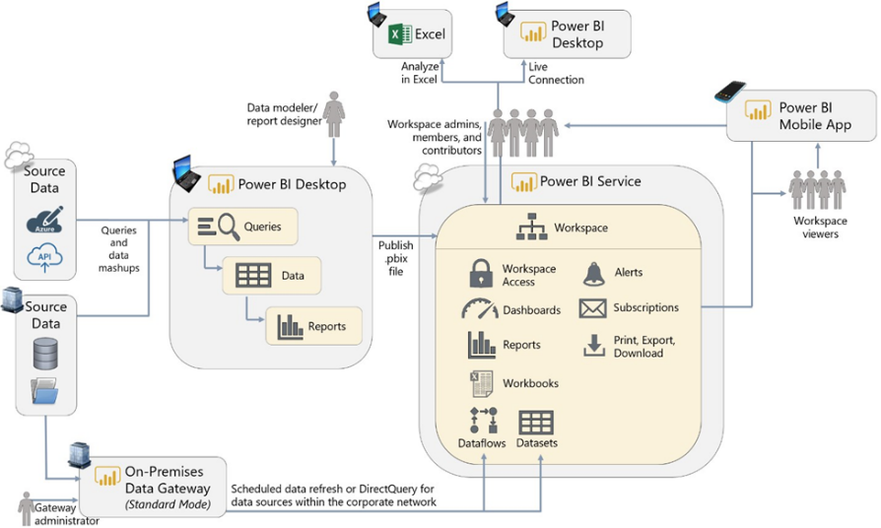

**Project Planning**

This is a crucial aspect of implementing the BI system, and it illustrates the activities and duration of takes and required resources. The anticipated development time is 59 days.

**3. Business analysis**

**Project requirement gathering.**

The curial aspect of the deployment process and workflows are discussed. Here, the organisation's needs, requirements, and objectives are highlighted, i.e. what questions will the BI system answer, what problems will it solve the BI system will answer, what problems it will solve, etc. The executives and managers proposed an initial solution to be adopted.

**Data Analysis**

The source data for analysis comes from the employee OLAP Cubes within the database SQL Server, obtained in the ETL process. The OLAP cube serves as the data source for Power BI as a dimension and facts table. First, the metadata is captured for the data. The star schema is developed using facts and dimension tables; then, various mathematical measures are used to query the data to build visualisations for analysis.

**Metadata Repository Analysis:**

A metadata repository allows users to register, annotate, discover, understand, and consume data sources. Ayaki uses the Database SQL Server data catalogue to store the metadata. The metadata provides table names, unique ids, structure, object description and table relationships. Having this in place will benefit key users to find the information about technical and end-user documentation they need in one place and potentially decrease duplication of effort for things that already exist. An excerpt of Ayaki's Employee table metadata is seen below:

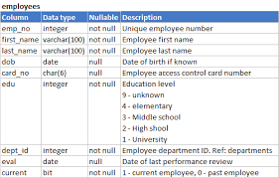

**Prototyping Application**

The leverage of prototyping techniques will confirm visual requirements and calculations with end-users before significant development time is incurred. Prototyping solutions may be temporary, or they may ultimately evolve into a fully validated solution by the end users and be released. For simplicity, this scenario illustrates sharing functionality for collaboration purposes.

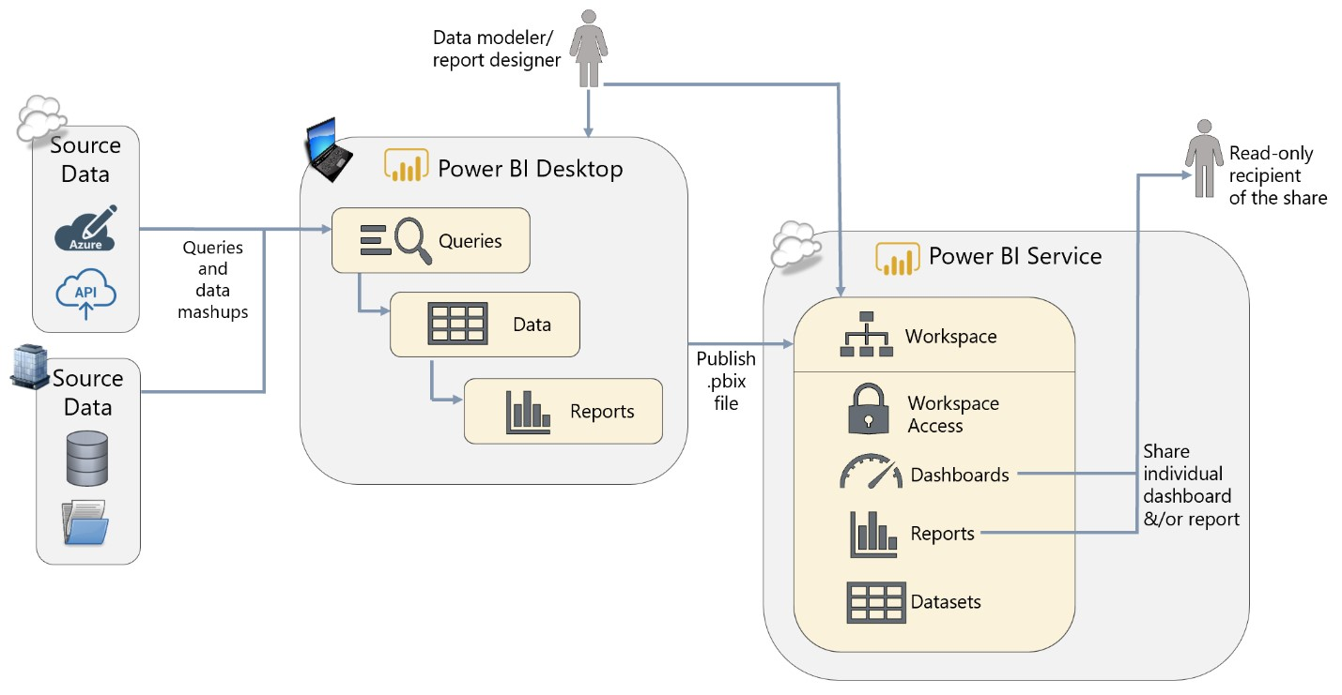

**4. Design**

**Database design**

The Database administrator, HR Manager and Executive will determine the business requirements for the HR dashboard. Database design involves classifying data and identifying interrelationships.

**However, the HR dashboard design process will consist of the following steps:**

1. Establish the **objective** of your database.
2. Locate and organise the information required to generate the HR dashboard.
3. Connect to the relevant in the SQL Server and obtain HR OLAP cube
4. Identify fact tables from dimension tables.
5. Specify primary keys and foreign keys.
6. Set up the table relationships.
7. Refine the visualisation design considering common dashboard mistakes (Few, 2006).
8. Apply the normalisation rules.

A simplified schema ensures the ad-hoc process for future analysis from the database. The mathematical measure will provide drill-down features within the dashboard. The time dimension and granularity further allow analysis by a period, department and other parameters.

**ETL Design**

Power BI follows an ETL-Extract, Transform and Load process to perform its functions.

Power BI allows users to automate extracting, transforming and loading data into internal tables to serve as reports in many formats, including PowerPoint and PDF. The ETL is done incrementally when the auto-refresh phase is tested and completed; each update in the ERP and Database automatically reflects.

**5. Construction**

**ETL development**

The ETL development will be packaged as a data pipeline to enable the continuous transformation of new data sets. This forms the primary integration system that will feed the data model, which will refresh incrementally as the data is updated. The ETL process is a sequence of applied data transformations that will be tested sequentially by the BI developer or manager before the full integration of the analysis phase is carried out.

**Application Development**

A prototype design of the application and model will be implemented for proper documentation and signoff. The prototype design will serve as a benchmark for the developed HR dashboard. Each phase of the report development will be projected to the end-user to ensure every business requirement is fully captured and implemented.

The dashboard will be released into the UAT phase following the prototype design projection. The end-user can interact independently with the HR dashboard for adequate feedback and modification using the UAT script.

The dashboard's final release into UAT will be tested by the HR manager, checking for the accuracy of the data. A training manual will be provided for end-users after the UAT phase.

**6. Deployment**

Before the HR Dashboard modification, a signed-off document must be obtained for the UAT testing for initial deployment to the production environment. After critical users’ final review and general acceptance of the HR dashboard, the application's last release will be deployed for daily usage.

**7. Implementation**

As part of the sure step process for deploying the HR application dashboard, end-users will conduct training to adopt the system.

A support phase is also implemented to assist and ensure the system's smooth running.

The support phase also includes the implementation of newly requested features from users.

**8. Release Evaluation**

A quarterly meeting is scheduled between the project teams to address any issues or subsequent add-ins requested by users.

# REFERENCES

Cecilia, O. (2014)*Business Intelligence Adoption: A case study in the retail chain.*University of Economics in Bratislava. Available at: http://www.wseas.us/journal/pdf/economics/2014/a185707-163.pdf (Accessed: 17 January 2021)

Chris, W. and Melissa, C. (2017) *Planning a Power BI Enterprise Deployment.*CA: Microsoft.

Few S. (2006) *Information Dashboard Design: The Effective Visual Communication of Data.*Gravenstein Highway North Sebastopol, CA: O'Reilly

Moss, L.T. and Atre, S. (2003) *Business Intelligence roadmap: the complete project lifecycle for decision-support applications.* Boston: Addison-Wesley Professional.